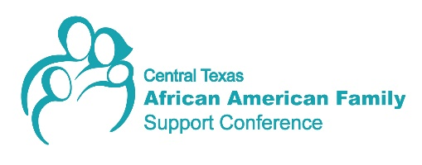

Fundraising & Sustainability/ Outreach Committees Meeting Minutes

Date: Wednesday, September 16, 2020

Time: 12 - 1pm

Via Zoom

Attendees: Lady Jane Acquah, Vicky Coffee, Mallinee Diggs, Kacey Hanson, Emmitt Hayes, Kimberly Holiday, Lisa Quinn, Ellen Richards, Fabian Wood

- Welcome and Introductions: Members greeted one another.
- Updates on Fundraising Sponsorship package: Ellen Richards gave an update on the finalized package being sent to previous sponsors. Next steps will include follow-up calls to sponsors from Emmitt Hayes, David Evans and Ellen Richards. Members are encouraged to review the packet on the conference website and offer any feedback to Integral Care staff. Members are also requested to help get conference information into local communications and newsletters.

- Pre-conference event: Fabian Wood provided an update on the event. Ideas for a virtual event included having several speakers, testimonials from past attendees and video clips from prior conferences. All would be used in a celebratory way to celebrate the success of the conference and as an ongoing promotion for donations. Fabian is working together with Mallinee Diggs for a possible outdoor component to the event. Budget of $2500 is based on last year’s event. Promotional videos should be completed by the end of November. Cross promotion for the event is being developed with Omega Fraternity to further expand reach of the conference.
- Outreach and Marketing strategy for a virtual event (Outreach): Lady Jane Acquah reported that outreach is ongoing and conference registration will open in October. Submissions for workshops and poster sessions is slow. Lady Jane is doing targeted outreach for workshops on specific topics.
- TogetherWeWillHeal in-kind sponsorship (Outreach): Kimberly Holiday reported forum topics can be integrated with potential sponsors (example: partnering with Sickle Cell Association of Texas).
- Other Business: Online shop for conference branded merchandise should open sometime in October.

